**AMD Awareness: Understanding Macular Degeneration**

[**Age-related macular degeneration**](https://www.aao.org/eye-health/diseases/amd-macular-degeneration) (AMD) is the most common cause of vision loss and blindness in Americans over age 50, affecting about 2.1 million people nationwide. Early diagnosis and treatment are the keys to preventing vision loss. During February, **Carlin Vision** and the [**American Academy of Ophthalmology**](https://www.aao.org/) are educating the public about the facts on AMD.

AMD is a degenerative disease that happens when part of the [**retina**](https://www.aao.org/eye-health/anatomy/retina-103) called the [**macula**](https://www.aao.org/eye-health/anatomy/macula-6) is damaged. It’s the part of the eye that delivers sharp, central vision needed to see objects straight ahead. Over time, the loss of central vision can interfere with everyday activities, such as the ability to drive, read, and see faces clearly.

Eye doctors have more tools than ever before to diagnose the disease earlier, and to treat it better. But these advances cannot help patients whose disease is undiagnosed, or patients who are unaware of the seriousness of their disease. People’s lack of understanding about AMD is a real danger to public health. One [**study**](https://www.ncbi.nlm.nih.gov/pmc/articles/PMC5640748/) showed that most people with AMD don’t realize it’s a chronic health issue that requires regular attention for the rest of their lives.

Learn more:

[Understanding Macular Degeneration - American Academy of Ophthalmology](https://www.aao.org/eye-health/diseases/amd-macular-degeneration)

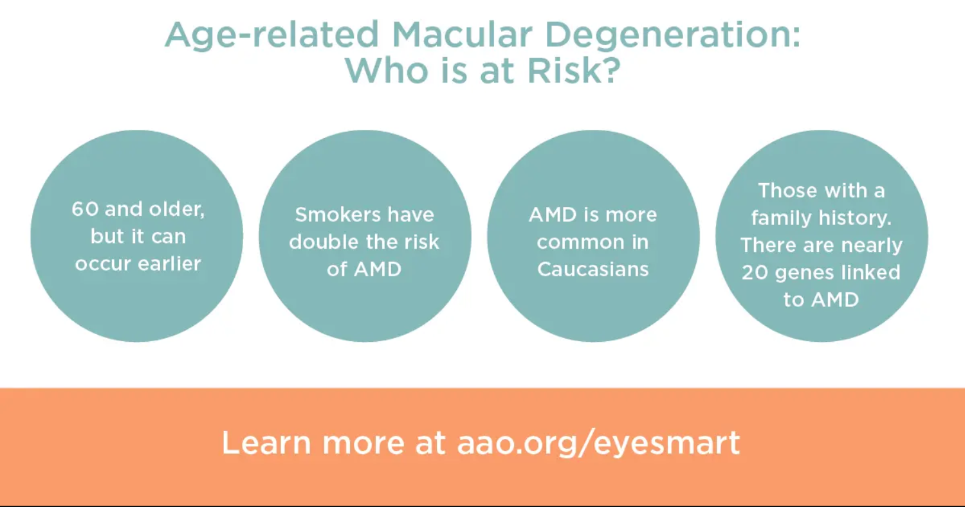

**Oh My Red, Itchy Eyes!**

Spring is right around the corner, but so are seasonal allergies. In the spring, Carlin Vision sees many patients with eye allergy complaints. Now is the time to learn more about how to manage these annoying symptoms

Eye allergies, also called allergic [conjunctivitis](https://www.aao.org/eye-health/diseases/pink-eye-conjunctivitis), are quite common. They occur when the eyes react to something that irritates them (called an allergen). The eyes produce a substance called histamine to fight off the allergen. As a result, the eyelids and [conjunctiva](https://www.aao.org/eye-health/anatomy/conjunctiva-3) become red, swollen and itchy. The eyes can tear and burn. Unlike other kinds of [conjunctivitis](https://www.aao.org/eye-health/diseases/pink-eye-conjunctivitis), eye allergies do not spread from person to person.

People who have eye allergies commonly have nasal allergies as well, with an itchy, stuffy nose and sneezing. It is usually a temporary condition associated with seasonal allergies.

You can get eye allergies from pet dander, dust, pollen, smoke, perfumes, or even foods. If you cannot avoid the cause, your allergies can be more severe. You can have significant burning and itching and even sensitivity to light.

Learn more:

[What Are Eye Allergies? - American Academy of Ophthalmology](https://www.aao.org/eye-health/diseases/allergies)

**Most Sports-Related Eye Injuries Can be Prevented**

New research shows that about 30,000 people in the U.S. go to emergency departments each year with sports-related eye injuries, a substantially higher estimate than previously reported. This April during Sports Eye Safety Month, **Carlin Vision** and the [American Academy of Ophthalmology](https://www.aao.org/) remind the public that the right protective eyewear is the best defense against eye injury.

Three sports accounted for almost half of all trips to the emergency room: basketball, baseball, and air/paintball guns. [Sports-related injuries](https://www.aao.org/eye-health/tips-prevention/injuries-sports) can range from [corneal abrasions](https://www.aao.org/eye-health/diseases/corneal-abrasion) and [bruises on the lids](https://www.aao.org/eye-health/diseases/black-eye) to more serious, vision-threatening internal injuries, such as a [retinal detachment](https://www.aao.org/eye-health/diseases/detached-torn-retina) and [internal bleeding](https://www.aao.org/eye-health/symptoms/blood-in-eye).

Here are some tips for both the professional athlete and the Little League star to stay safe:

Read more:

[Ophthalmologists Urge Eye Protection for Recreational and Professional Sports - American Academy of Ophthalmology](https://www.aao.org/newsroom/news-releases/detail/ophthalmologists-urge-eye-protection-sports)

